**Paper Notes**

*Prediction of Future Injury in Sport: Primary and Secondary Anterior Cruciate Ligament Injury Risk and Return to Sport as a Model*

* **Contamination:** if a study of athletes is contaminated by prior interventions relating to a modifiable outcome variable that’s used as a risk indicator, a large percentage of subjects may have been unknowingly exposed to outcome-altering interventions.
  + The timing, volume, and duration of interventions before and after screening must be accounted for, quantified, and included in any valid prediction model
* **Surveillance:** a flawed injury surveillance system and the extended and varying time between screening and injury
* **The Flaw of Normalization:** normalizing should be avoided in the development of predictive injury models. This team found in their previous study that non normalized knee abduction was highly predictive of injury risk, but normalized knee abduction was not able to predict ACL injury in mixed-effects logistic regression models.
  + Basically, non-normalized data had more predictive capabilities
  + Reasoning: normalized events and moments aren’t naturally occurring, therefore they cannot be soundly used for prediction
* **Injury Prediction and the Second Injury Dilemma**
  + Obviously, the best predictor for a second injury is a prior injury
* Overall, they don’t have any real results to share. They believe themselves experts on injury prediction and give guidelines on what future projects should do. Honestly, they seem rather pompous in their writing, but that’s just me.

*Repeated Exposure to Established High Risk Workload Scenarios Improves Non-Contact Injury Prediction in Elite Australian Footballers*

* Objective: assess the effect of multiple high-risk scenario exposures on injury prediction
* Methods: sessional workload data (GPS derived distance, sprint distance, max velocity) from 60 players over 3 seasons
  + Univariate and multivariate Poisson regression models were used to find incident rate ratios
  + Model performance was evaluated using ROC (AUC)
* Results: very low and very high exposures to >85% of a player’s max velocity over the previous 8 weeks were associated with greater injury risk compared to moderate exposure, with model performance of AUC = .64 (which isn’t very good imo)
* Minimal exposure to high velocity efforts was associated with the greatest injury risk. Being under-loaded may be a mediator for non-contact injury. Pre-season workload and playing experience weren’t moderators of this effect
* Overall, these results make me suspicious. Not sure if we should really trust them, seeing as their results really weren’t that good

*Physical Exam Risk Factors for Lower Extremity Injury in High School Athletes: A Systematic Review*

* Objectives: identify clinical assessment tools demonstrated to effectively determine lower extremity injury risk in a prospective setting & critically asses the methodological quality of prospective lower extremity risk assessment studies that use these tools
  + They basically did a literature survey
* 9 studies were looked at
  + Identified risk factors fell into 7 basic categories: balance, anatomy, strength, physical maturation status, weight, and ligamentous laxity
  + They also go into detail on why they think each of these 7 categories are significant
* Overall, this is a decent paper to reference to when we talk about what variables are important in injury prediction. It also has a LOT of sources in it that we could also point to if needed

*A Model of Stress and Athletic Injury – Prediction and Prevention*

* In short, this covers how stress related factors can affect injury occurrence
* It also talks about the necessity to thoroughly investigate these different sources of stress, how they play on one another, and what they actually mean for the player
* I feel this is somewhat accomplished by the OWI and SFI tests in our data

*Free Communications, Oral Presentations: Lower Extremity Movement Screening and Injury Prevention*

* Objective: identify pre-participation screening measures that demonstrate a substantial association with subsequent CLEI for high school football players
* Outcome Measures: retrospective and prospective analyses were performed to assess associations between screening measures and injury
  + Retrospective injury = any CLE sprain or strain resulting in sport time loss
  + Prospective injury = any CLE sprain or strain during the season that required evaluation and treatment
* Also used a Sport fitness index (SFI) score in their testing to quantify persisting effects of previous injuries
* Prediction models were made from ROC and logistic regression
* Conclusion: pre-season screening results can be used to estimate the injury risk level of individual high school football players

*Injury Prediction in Veteran Football Players using the Functional Movement Screen*

* The main take away for this, I think, is that they also used a sort of Movement based screening for injury prediction (similar to the lateral and horizontal movement tests Gary did)
* But, these are on veteran football players (age >32), not high school and college students
* Maybe not a good paper for a direct comparison, but good to bring attention to if we end up using those movement based variables in the study

*Data Preparation for Injury Prediction*

* The stuff in here is pretty obvious, but it’s another source we can point to

*Association of Concussion History with Neuromechanical Responsiveness Asymmetry*

* Goal: derive a generalizable statistical model for identification of athletes who possess subtle alterations in sensorimotor processes that may be due to previous concussions
* Tested in residential Olympic training center sports medicine clinic
* Consisted of a primary cohort of 35 elite athletes, and a second cohort of 40 different elite athletes who performed identical tests the preceding year
* Testing done: 2 upper extremity tests of visual-motor reaction time and 2 tests of whole-body reactive agility
  + Whole body test required lateral or diagonal responses to VR targets
* Outcome:
  + Sport-related concussion history (SRC Hx) which was reported by 54% of the primary cohort athletes, and 45% of the second cohort athletes
* Results: univariate analysis identified 12 strong predictors of SRC Hx (see table below)

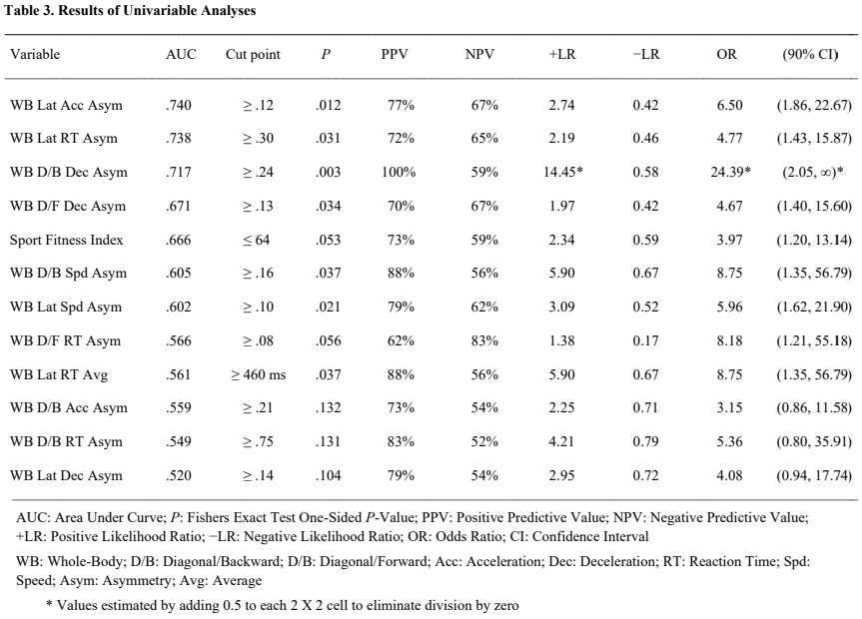

* Conclusions: asymmetry in whole-body reactive movement capabilities may be a manifestation of a subtle abnormality in the functional connectivity of brain networks that might be relevant to previously reported associations between SRC Hx and musculoskeletal injury occurrence

*Effective Injury Prediction in Professional Soccer with GPS Data and Machine Learning*

* Uses GPS measurements and machine learning to predict injury occurrence in soccer players
* GPS is used to collect workload of players during a season (workload seems to be a common area of interest in these papers)
* They monitored the physical activity of players during 23 weeks of training sessions
* Used tools like GPS tracker, 3-d accelerometer, 3-d gyroscope, and 3-d digital compass
* Features used in study:

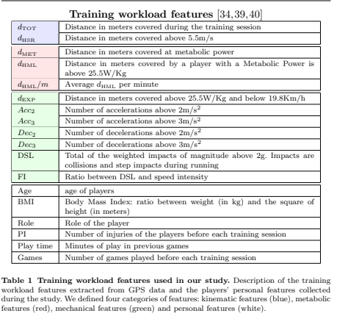

* They broke down their approaches as follows:
  + ACWR (acute chronic workload ratio): the ratio between the acute workload and the chronic workload of a player
  + MSWR (mean standard deviation workload ratio): the ratio between the mean and the standard deviation of a player’s workload obtained in 1 week
* They have a decision tree model named Call, but I can’t find a direct explanation of what it is

*Risk for Lower Extremity Injury After Concussion: A Matched Cohort Study in Soldiers*

* The rate of lower extremity musculoskeletal injuries is reportedly higher in collegiate and professional athletes following concussions
  + It’s hypothesized that the increased risk is due to the persistence of post concussive symptoms or neuromotor deficits
  + There’s a whole paragraph listing the things that are a result from concussions that could cause more injury occurrence
* Objective: examine the risk of acute lower extremity musculoskeletal injury in soldiers within 2 years of an incident concussion, compared to matched non-concussed soldiers
* Used medical encounter and personnel data of active duty US Army soldiers from 2005 to 2011. Incident concussions were identified using Integrational Classification of Diseases-9th revision code in medial encounter data of all soldiers from 2005 to 2009. One non-concussed soldier in the army during the same month was matched by age, sex, rank, service time, deployment status, and military career field to each concussed soldier.
* Results: within 2 years of concussion, the hazard of lower extremity injury was 38% higher in concussed compared to non-concussed soldiers, while 15-month hazard was 45% higher.

*Predicting the Risk of Injury of Pro Football Players with ML*

* Monitoring and analyzing player data are critical to ensure that players receive a suitable training schedule and given a suitable recovery time between matches and training sessions
  + This is a good justification for doing the project and what support it can provide
* Paper breaks down how the importance of injury prediction into 4 categories:
  + Player performance, player psychological impact, team performance, and economic impact
* Objectives:
  + Perform an exploratory data analysis to uncover data quality problems, reveal data insights, and apply the needed transformations
  + Investigate different types of data aggregation operations to maximize the knowledge extraction and create a dataset that can be used for accurate injury prediction
  + Evaluate different machine learning models and accuracy measures, comparing them against a test dataset
  + Select the most accurate model for injury prediction, considering the accuracy measures
* Considered using many different models, including naïve bayes, linear discriminant analysis, support vector machines, artificial neural networks, and ensemble methods (one of which was XGBoost)
* Conclusions:
  + EDA uncovered missing data in different variables and an unbalanced dataset with the target variable having only 1.9% of the total observations.
  + Data was aggregated by weekly micro cycles as it usually contains different training intensities and one match, as well as being a frequently used measure in football
  + The ROSE sampling technique with XGBoost algorithm was considered the most accurate model looked at
  + The model can be used to determine training load thresholds for individual players, above which, injury risk substantially increases
  + The algorithm provides a useful way to combine the different features and swiftly flag players in the risk of injury

*The Persistent Influence of Concussive Injuries on Cognitive Control and Neuroelectric Function*

* Objective: to evaluate the influence of concussion incurred during early life on the cognitive control and neuroelectric function of young adults
* Participants: 40 young adults separated into groups according to concussive history. All participants incurred all injuries during sport and recreation before 18 years old, and were an average of 7.1 +- 4 years from injury at the time of study
* Results: compared to the control group, the concussion group exhibited decreased P3 amplitude during target detection within the oddball task and during the heterogeneous condition of the switch task. The concussion group also displayed increased N2 amplitude during the heterogeneous version of the switch task. Concussion history was associated with response accuracy during the flanker test.
* Conclusions: people with a history of concussion may demonstrate persistent decrements in neurocognitive function, as evidenced by decreased response accuracy, deficits in the allocation of attentional resources, and increased stimulus-response conflict during tasks requiring variable amounts of cognitive control. Neuroelectric measures of cognitive control may be uniquely sensitive to the persistent and selective decrements of concussion.

*The Persistent Influence of Pediatric Concussion on Attention and Cognitive Control During Flanker Performance*

* Consisted of 32 children (ages 8-10), 16 with a concussion history, 16 control.
* Completed compatible and incompatible conditions of a flanker task while behavioral and neuroelectric data were collected.
* Relative to controls, children with a concussion history exhibited alterations in the sequential congruency effect, committed more omission errors, and exhibited decreased post-error accuracy. Children with a concussion history exhibited N2 latency across task conditions, increased N2 amplitude during the incompatible condition of the task, and decreased P3b amplitude across task conditions. Children with a history of concussion also exhibited decreased ERN and Pe amplitude with difference increasing for the incompatible condition of the task
* Current results indicate that pediatric concussion may lead to subtle, but pervasive deficits in attention and cognitive control